Session 4– Connecting to Databases (Part 1)
Labs

Lab 1- Connecting and Retrieving Data from an Access Database Using a
Servlet

- Create a database titled movies using the NetBEans packaged JavaDB as follows

- Open the Services tab on Netbeans -> Right click on JavaDB -> Create database .
- The Create JavaDB Database window will open. Type the following data in the appropriate fields:
Database Name -> movies
User Name -> user1
Password -> password
Click OK to create the database
- Right click on the created database -> Connect
- Expand the database folder as shows below

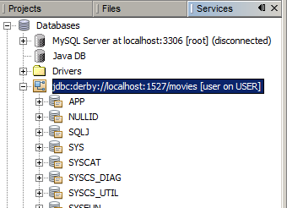

- Expand the APP folder -> Right click Table -> Create Table named TMovies, with the following structure

ID ->integer
TITLE -> VarChar (size -50)
RATING -> VarChar(size -2)
PRICE -> Double
QUANTITY -> integer
CATEGORY -> VarChar(size-15)

- Populate the database with some data . Right click on the TMovies table -> View Data. The following windows would be displayed.
- Select the + to add a new record.

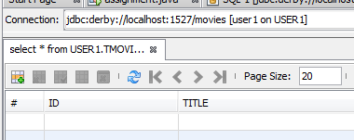

- Create a new Web project and add a new Servlet to the project with the following properties:
Name of Servlet Class: DBServlet1
Package Name: s4
URL Pattern: /db1

- Delete the processRequest( ..) method in the servlet and replace it with the processRequest( ) code in the DBServlet1.txt file located in the Session 4 Resources folder.
Add the following import statements to your servlet
import java.sql.Connection;
import java.sql.DriverManager;
import java.sql.ResultSet;
import java.sql.ResultSetMetaData;
import java.sql.SQLException;
import java.sql.Statement;

- Run the Servlet which should return all the movies in the Tmovies table

Using a Class to format your data in a HTML Table
Typing all those out.println () statements to format and display your data in a HTML table format is quite tiresome. To make things easier I have written a Class to take care of the formatting. Code reuse is the something we should strive to do at all times, and this is a good example.

Lab 2
- Create a new Servlet titled DBServlet2, use the URL Pattern db2
- To use the TableFormatter class you will need to add the CourseWebComponents.jar file ( located in the subject shared network drive in the Session 4 Resources\Tafe Course Web Lib folder), your Web project Libraries ( Libraries ->Add Jar/Folder , and navigate to the .jar file (see image below)

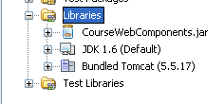

- Delete the processRequest( ) method and replace it with the processRequest( ) found in DBServlet2.txt file found in the Session4 resources file.
- Delete the following code in the pasted processRequest( ) method as shown below:

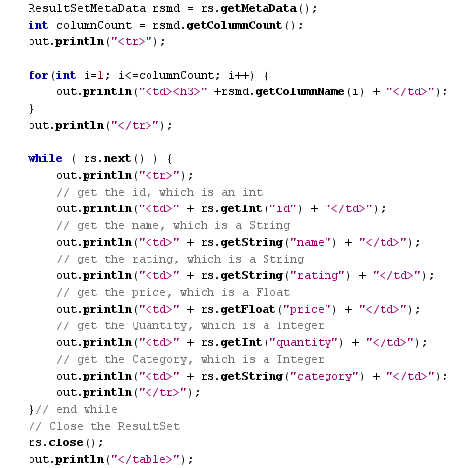
- Now, add this the line of code highlighted, make sure you import java.sql and the TableFormatter class found in the tafe.java.web package:

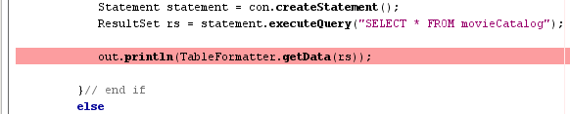
Add this code here
TMOVIE

- Run the Servlet and observe the results.

Lab 3 (Core)
Create a new Database titled BookDB and create a new table to hold the details of several books. Now create Servlet to display the details of the books from the database., using the TableFormatter class to create the output to be displayed.

Making your Servlet -Database portable
Think about how you could make your Servlet database independent.
If we hard-wire the database driver and connection url in our Servlet this would mean that if we changed the table names, location and security credentials of the database, or even the type of database, we would have to make changes to our Servlet and recompile the servlet for the changes to take effect.

We now look at several strategies for achieving database portability and ease of maintenance.

1. We put all the connection and database details in the Web.xml file as init parameters.
If we have to make any changes in the future, it is simply a simple matter of changing THE VALUES IN THE Web.xml file, and our Servlet remains untouched.

2. We implement all database access details in a separate Data Access Object (DAO) and
Implement different versions for each type of database. (More about this later)

3. We create a DataSource to manage the connection details through a simple xml file that is used by the Web Container such as GlassFish or Tomcat

We will first look at 1st strategy and later at the other two strategies.

Lab 04– Creating and using initialization parameters in your Servlet.

- Create a new Servlet with the following details:
Servlet Name –->DBServlet3
URL Pattern -> /db3
Enter the Initialization Parameters as shown below using the ‘New’ button

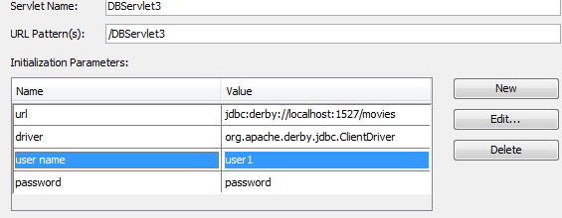

- Click ‘Finish’.

- Open your Servlet and replace the processRequest( ) with the processRequest( ) in DBServlet2.
- Replace the code shown below:
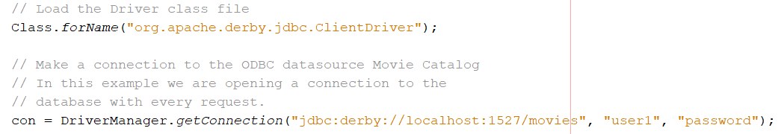
With this code:
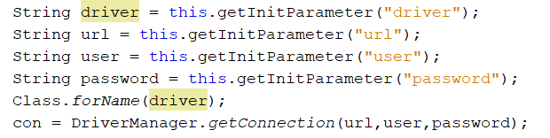

- Run the application.

Using a Data Access Object (Strategy 2)
Using a Servlet to handle both the application and persistence logic is not considered good programming practice. The use of a Data Access Object to abstract and encapsulate all access to a persistent store is considered a better approach.

The Data Access Object (DAO) implements the access mechanism required to work with the data source.
Regardless of what type of data source is used, the DAO always provides a uniform API to its clients.
The DAO completely hides the data source implementation details from its clients (in this case the Servlet).
This allows you to change the Data store without changing the DAO client’s implementation. Essentially, the DAO acts as an adapter between the client and the data store.
In the above example if I change the data store from JavaDB to say Oracle, I would have to make the necessary changes to the Servlet. By using a DAO I simply substitute the JavaDBDAO with an Oracle DAO and my Servlets interaction with the new DAO would not change.
More of this later but for now we will use a Generic DAO that could connect to any data store and retrieve data, which could then be formatted by the TableFormatter class.
The Servlet would use the init parameters to pass the database URL, driver and table to this DAO.

Lab 05–Using a Generic DAO as a Data Tier (Core)
- Create new Servlet titled DBServlet4 and set the following init parameters :

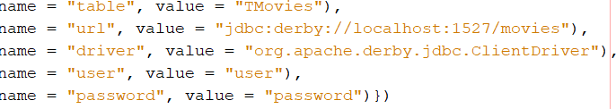

- Use an instance of the GenericDAO to connect to the database and return a
Resultset to the Servlet. Read the documentation found in the session 4 Resources/Tafe Course Web Lib\javadoc, to understand how to use this class.

Have a go yourself, and if you have any difficulties, a copy of the processRequest( ) method and replace the same method found in the DBServlet4.txt file

- Modify the Servlet to display a list of movies where the Rating is ‘PG’.

- Modify the Servlet to Display all the Action movies.

- Add a HTML page to your project that has a set of links that would allow a user to select either all the movie titles in the database or movie titles based on the movie category – see an example page below
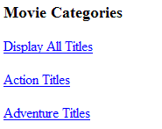
<a href="db4">Display All Titles</a></br>
<a href="db4?name=Adventure">Display Adventure Titles</a></br>
<a href="db4?name=Action">Display All Action Titles</a>

